Azure App Services

1. Deploy a HTML Web Application in Azure App Services

Step 1: Go to azure portal and open cloud shell.

Run the following commands:

mkdir quickstart

cd $HOME/quickstart

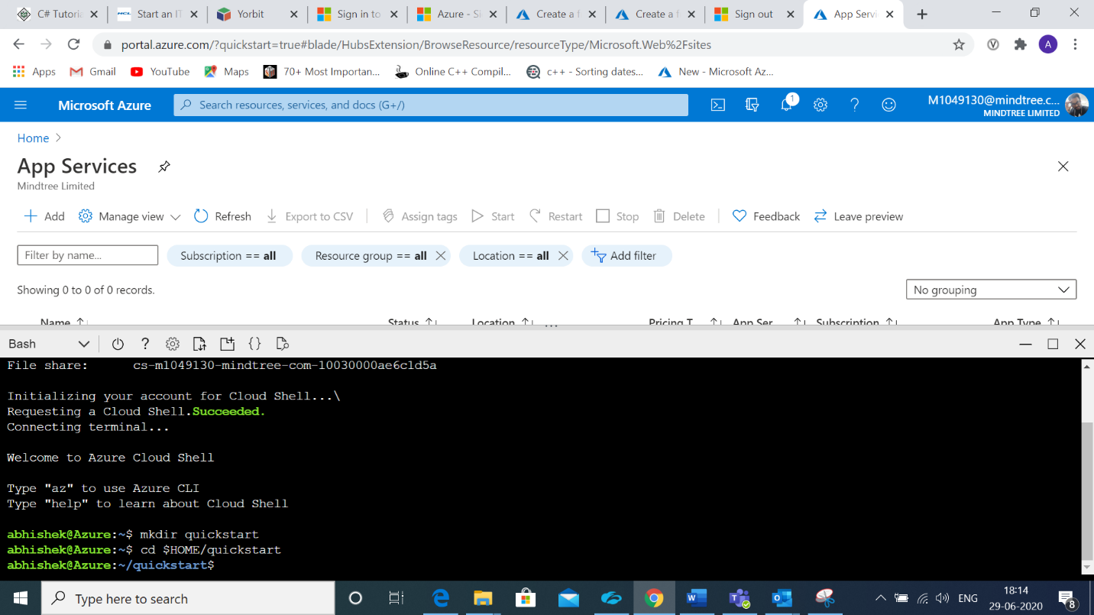

Step 2: Create a webapp using the following commands:

cd html-docs-hello-world

az webapp up --location westeurope --name koushik

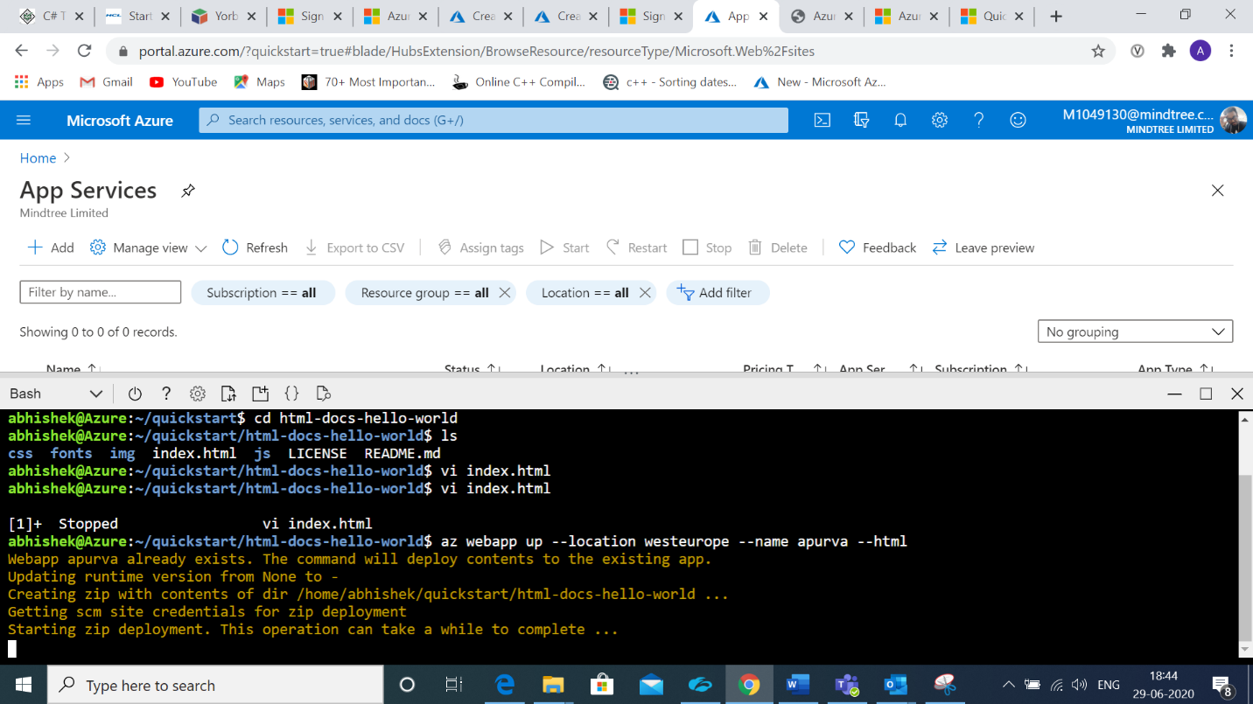

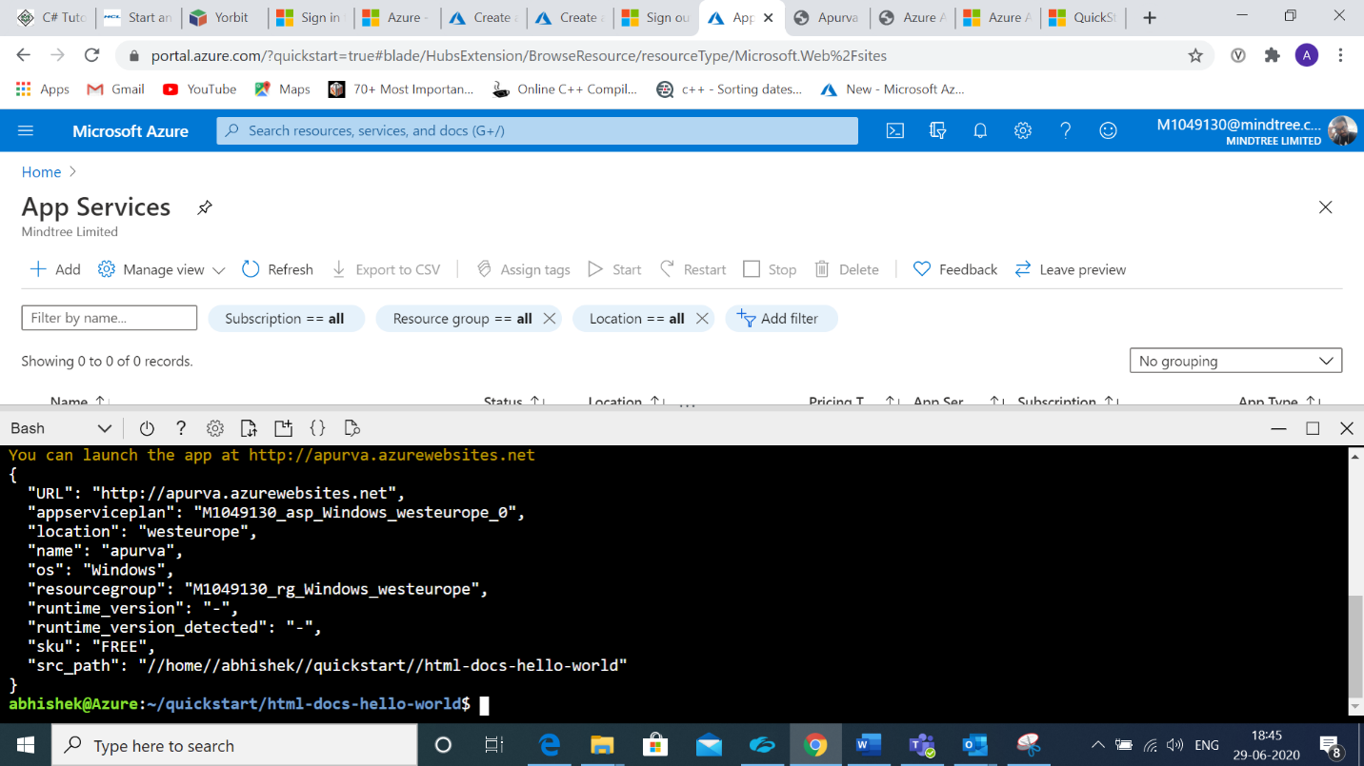

We get the following as the output.

{

"URL": "http://apurva.azurewebsites.net",

"appserviceplan": "M1049130_asp_Windows_westeurope_0",

"location": "westeurope",

"name": "apurva",

"os": "Windows",

"resourcegroup": "M1049130_rg_Windows_westeurope",

"runtime_version": "-",

"runtime_version_detected": "-",

"sku": "FREE",

"src_path": "//home//abhishek//quickstart//html-docs-hello-world"

}

We can access the application in the <https://apurva.azurewebsites.net/>.

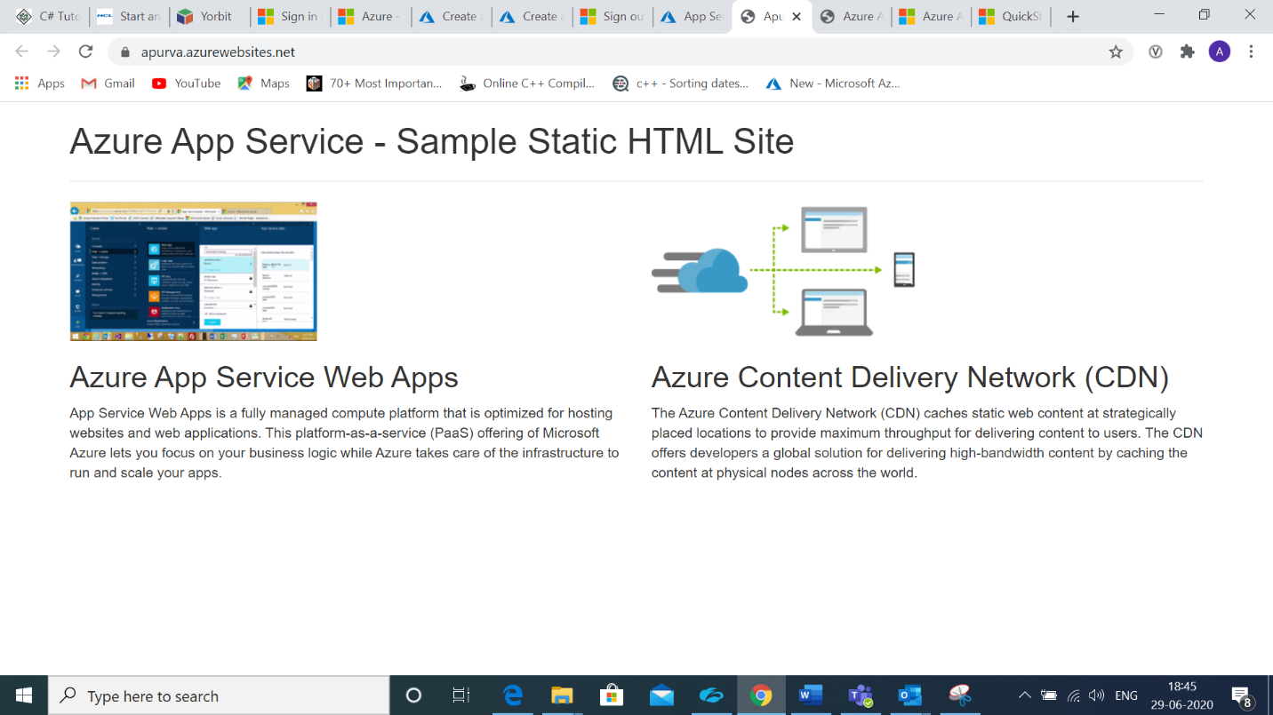

Step 4: Update the sample web application by making a few changes in the web page( i.e in index.html).

Now run the following command again to bring up the application

az webapp up --location westeurope --name <app_name>

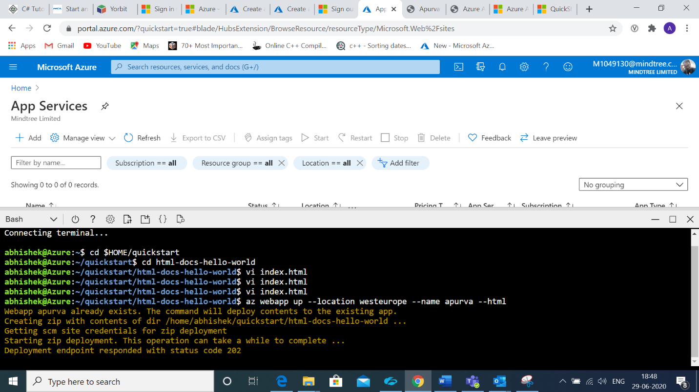 We get the message as the webapp is updated and deployed.

Step 5: Go to the website <https://apurva.azurewebsites.net/> and refresh the page. We can see the changes made in our webpage by editing index.html.

